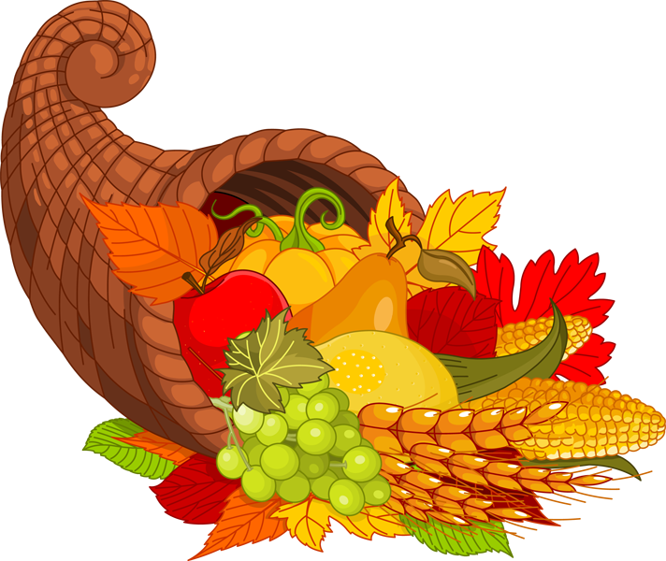 HAPPY THANKSGIVING

MENU FOR THE WEEK OF October 28th-November 1st
Mon-Hot dog and beans, roll, and dessert
Tues-Chicken, rice and peas, dinner roll, Chocolate chip cookie
Wed-Meatball sub, chips, cucumbers, ice cream sandwiches,
Thurs-Blueberry waffles, bacon, fresh fruit
Fri- Little Caesar’s Pizza

MENU FOR THE WEEK OF November 4th- 8th
Mon-Hot dog on a roll, beans, fruit
Tues-Tacos with all the fixings, corn, chocolate chip cookie
Wed-Ziti with sauce and cheese, salad, brownie
Thurs-French toast bagels, cream cheese, fresh fruit cup
Fri-Lunch in/out with families

MENU FOR THE WEEK OF November 11th-15th
Mon-NO SCHOOL
Tues-Chicken noodle soup, crackers, cookies
Wed-Mac & Cheese, green beans, peaches
Thurs-French toast sticks, bacon, yogurt
Fri- Little Caesar’s Pizza

MENU FOR THE WEEK OF November 18th-22nd
Mon-Chicken nuggets, French fries, peas, brownies
Tues-Taco Salad with corn chips, corn, popsicles
Wed-Chocolate Pancakes, sausage patties, apple sauce
Thurs-Thanksgiving Dinner- Turkey, Stuffing, Mashed Potatoes, Gravy, Corn, Cranberry Sauce, Apple Pie
Fri- Little Caser’s Pizza

MENU FOR THE WEEK OF November 25th-29th
Mon-Waffles, sausage links, apple sauce
Tues-Tacos w/all the fixings, corn, Chocolate chip cookies
Wed- Little Caser’s Pizza
Thurs- NO SCHOOL
Fri-NO SCHOOL

Pre K through Eighth Grade may purchase the following items on a daily basis: Peanut Butter and Jelly or Fluff, Tuna Sandwich, Ham and Cheese Sandwich, Bologna and Cheese Sandwich, Turkey and Cheese Sandwich, Chicken Patty Sandwich, Chicken nuggets, Hamburger or Cheeseburger, Hotdog on a roll, Corn Dog, Grilled Cheese Sandwich, Pizza, or a Loaded Baked Potato w/all the fixings. (These items come with chips, veggie, and dessert) Also available for purchase in the café are chips, ice cream sandwiches, hoodies cups and assorted baked goods. Snacks are priced from .25 cents to .75 cents

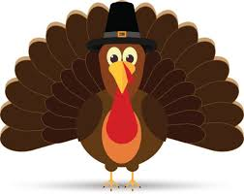 MENU SUBJECT TO CHANGE WITH NOTICE

